# Brainstorm

**TIP**

You can select a sticky note and hit the pencil [switch to sketch] icon to start drawing!

## Before you collaborate

#### A little bit of preparation goes a long way with this session. Here’s what you need to do to get going.

**10 minutes**

**1**

## Define your problem statement

#### What problem are you trying to solve? Frame your problem as a How Might We statement. This will be the focus of your brainstorm.

##### 5 minutes

**2**

## Brainstorm

#### Write down any ideas that come to mind that address your problem statement.

##### 10 minutes

Deep learning techniques be applied

Dharma**n M**

**TIP**

Add customizable tags to sticky notes to make it easier to find, browse, organize, and categorize important ideas as themes within your mural.

Categorise similar foods.

Motivation for weight loss.

Instant food recognition.

Database to display nutrient contents.

SUGGESTIONS

**3**

## Group ideas

#### Take turns sharing your ideas while clustering similar or related notes as you go. Once all sticky notes have been grouped, give each cluster a sentence-like label. If a cluster is bigger than six sticky notes, try and see if you and break it up into smaller sub-groups.

##### 20 minutes

**4**

## Prioritize

#### Your team should all be on the same page about what's important moving forward. Place your ideas on this grid to determine which ideas are important and which are feasible.

**20 minutes**

## After you collaborate

You can export the mural as an image or pdf to share with members of your company who might find it helpful.

**Quick add-ons**

# & idea prioritization

Use this template in your own brainstorming sessions so your team can unleash their imagination and start shaping concepts even if you're not sitting in the same room.

1. **Team gathering**

Define who should participate in the session and send an invite. Share relevant information or pre-work ahead.

1. **Set the goal**

Think about the problem you'll be focusing on solving in the brainstorming session.

1. **Learn how to use the facilitation tools**

Test with mutiple test cases.

Nutrition in the food is classified.

Recognize nutrients in food

Science is increasingly showing just how critical nutrition is to healing and recovery.

Nutrition and Physiotherapy.

Alert them to eat their food on time.

Identify multiple foods

Provide dietary advice

Imaya B

It includes age, body weight, height, food allergies, preferred diet.

Images processing to identify food

1. **Share the mural**

**Share a view link** to the mural with stakeholders to keep them in the loop about the outcomes of the session.

1. **Export the mural**

Export a copy of the mural as a PNG or PDF to attach to emails, include in slides, or save in your drive.

Maintaining the diet plan as per the schedule.

Meditate to relieve life stress.

Avoid sugar and sugar - sweetened drinks.

Make sure they get a Quality Sleep.

**10 minutes** to prepare

**PROBLEM**

**Poor nutrition can contribute to stress, tiredness and our capacity to work, and over time, it can contribute to the risk of developing some illnesses and other health problems such as being overweight or obese, tooth decay, high blood pressure and etc. To maintain and analyze the nutrition in our everyday food with the help of today's technology?**

These applications help users lose calorie and weights without harming their health. In other words, they mainly focus on healthy eating.

**1 hour** to collaborate

**2-8 people** recommended

Use the Facilitation Superpowers to run a happy and productive session.

[**Open article**](https://support.mural.co/en/articles/2113740-facilitation-superpowers)

Collect the information about the nutrients.

**Key rules of brainstorming**

Instant food reconisation.

Suggest food alternative.

To run an smooth and productive session

### Keep moving forward

**Strategy blueprint**

Define the components of a new idea or strategy.

[**Open the template**](https://app.mural.co/template/e95f612a-f72a-4772-bc48-545aaa04e0c9/984865a6-0a96-4472-a48d-47639307b3ca)

**Customer experience journey map**

Understand customer needs, motivations, and

Stay in topic. Defer judgment.

Suggestion are made.

This let them create the best diet plan

All of these can enable users to change to healthy meal habits

Analyze about their day to day activities

Encourage wild ideas. Listen to others.

**Sivanesan M**

Make them happy to relieve from stress

These types of special diet apps target a certain audience and are highly effective.

Date base to display nutrient contents.

**Rajkumar S**

Recognize nutrients in food.

Images processing to identify food.

Acts as a diet consultant.

### Importance

If each of these tasks could get

Alert them to eat their food on time

Alert

Notify them of their fat consumption.

Giving warning whatever misses their scheduled diet plan.

Informing them of various easily available food rich on whatever they require.

Indicating the every diet plan as alarm

obstacles for an experience.

[**Open the template**](https://app.mural.co/template/b7114010-3a67-4d63-a51d-6f2cedc9633f/c1b465ab-57af-4624-8faf-ebb312edc0eb)

BY TRACKING THE INTERVAL BETWEEN EVERYTIME THEY EAT

Give them a easiest diet chart to eat.

Answers the questions.

Decision tree.

**Strengths, weaknesses, opportunities & threats**

If they lose that much body weight, then they get their money back otherwise, they will lose the money.

Go for volume. If possible, be visual.

done without any difficulty or cost, which would have the most positive impact?

Identify strengths, weaknesses, opportunities, and threats (SWOT) to develop a plan.

[**Open the template**](https://app.mural.co/template/6a062671-89ee-4b76-9409-2603d8b098be/ca270343-1d54-4952-9d8c-fbc303ffd0f2)

Categorise similar foods.

|  |  |
| --- | --- |
|  |  |
|  |  |

**Lokesh M**

suggest food alternative

Giving them a proper diet plan

Define the features that you want to integrate into your diet and nutrition applications.

**TIP**

Participants can use their cursors to point at where sticky notes should go on the grid. The facilitator can confirm the spot by using the laser pointer holding the **H key** on the keyboard.

Track their sleep cycle

Track their information

The exact make-up of a diversified, balanced and healthy diet will vary depending on the individual needs.

Good nutrition with ingredients recipes.

Use a food diary to track your nutrition.

[**Share template feedback**](https://muralco.typeform.com/to/CiqaHVat?typeform-source=app.mural.co)

Identfy multiple food

Nutrition based analytics and data to its users.

People are consuming more foods high in energy, fats, free sugars or salt/ sodium.

Understand multiple foods.

[**Share template feedback**](https://muralco.typeform.com/to/CiqaHVat?typeform-source=app.mural.co)

Use a food diary to track your nutrition

Track their calories by using the information in the internet

By tracking the interval between every time they eat.

### Feasibility

Regardless of their importance, which tasks are more feasible than others? (Cost, time, effort, complexity, etc.)

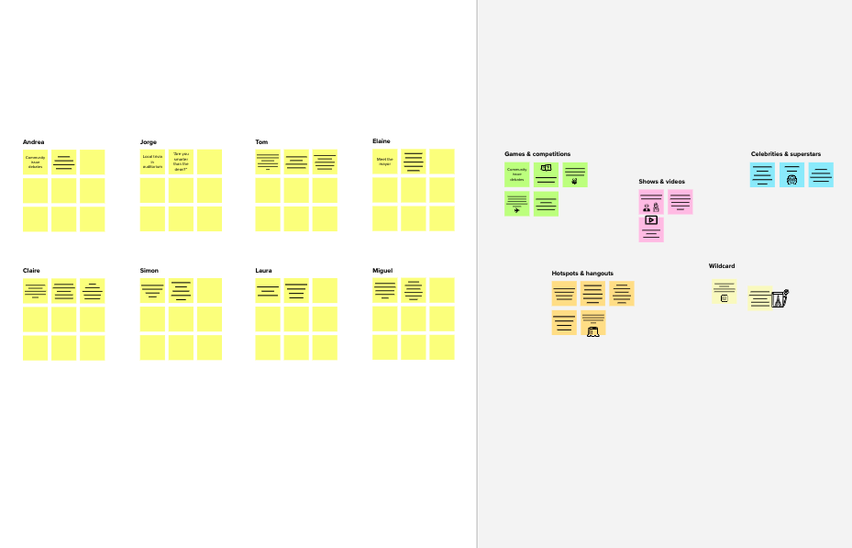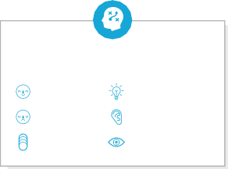

**Template**

**Need some inspiration?**

Track their sleep cycle.

Recognise nutrients in food.

Define the features that you want to integrate into your diet and nutrition applications.

See a finished version of this template to kickstart your work.

[**Open example**](https://app.mural.co/template/e5a93b7b-49f2-48c9-afd7-a635d860eba6/93f1b98d-b2d2-4695-8e85-7e9c0d2fd9b9)